**Observations through the Mobile Application**

* For Ionizing Radiations
  + Several readings of the Geiger counter were taken in account.
  + The average of the 10 readings taken is 0.033 μSv/hr
  + While the average of the readings taken with mobile phone around has the same value with a very negligible difference.
  + This also agrees with the fact that mobile radiations are not Ionizing in nature.
* For Non Ionizing Radiations
  + The average of the resultant magnetic field around the Mobile Phone (Observer) was found to be 39μT
  + Several observations from the observer’s mobile phone were taken :
    - Device model: Redmi Note 5 Pro

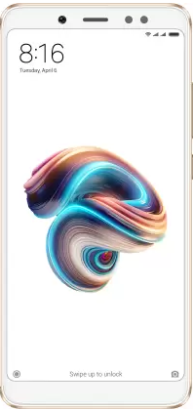

The maximum reading found for Magnetic strength was 1186 μT

* Device model: Samsung Galaxy M12

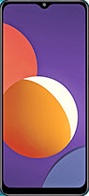

The maximum reading found for Magnetic strength was 1193 μT

* Device model: Redmi 8A Dual

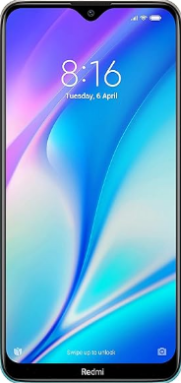

The maximum reading found for Magnetic strength was 1018 μT

* Device model: Oppo A16E

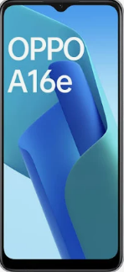

The maximum reading found for Magnetic strength was 1203 μT

* Device model: Moto G4 plus

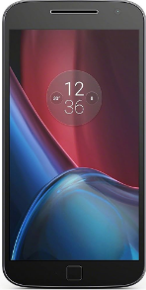

The maximum reading found for Magnetic strength was 5096 μT

**Suggestions**

1. As the application gives the vague idea of the radiation emitted by the mobile phones, teenagers and school students can be made aware of hazards that may occur when using mobile phones a for long duration.
2. As there are ample of online applications available for measuring the radiation emitted this study can motivate and boost other students / peer groups to showcase their creativity, as it is based on learning by doing
3. As the mobile app is self made, hands-on experimentation is further strengthened.
4. Family members can be appraised about the radiation emitted by practically using the application.

**More real-life use-cases**

1. The application can not only be used for giving an approximation of the surrounding radiation but the application can also be used to detect any smart hidden devices like hidden cameras, microphones, etc. using the “Non Ionizing radiation” feature. This works as follows, as we take the mobile closer to any smart device, we can observe an increase in the magnetic strength emitted by the device.
2. The application can to some extent also detect ferromagnets, like Iron, using the “Non Ionizing radiation” feature of the app. We can observe an increase in the magnetic strength as we take the mobile phone (observing phone) closer to the ferromagnet.

**Solution to the problem**

As mobiles have become an integral part of our life, it cannot be separated and the radiation emitted cannot be eliminated completely. But few parameters can be a part of the solution to the problem:

1. Number of hours of usage can be brought down.
2. WiFi / Mobile data can be turned off when not in usage.
3. Mobile phones can be placed away from our sleep area.
4. Awareness related to its hazards can be given during school assembly.

**Screenshots of the application and pictures of the Geiger Module Box**

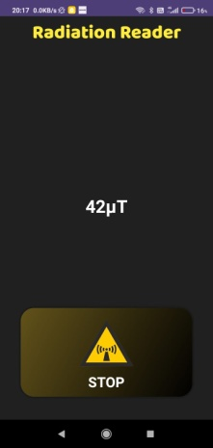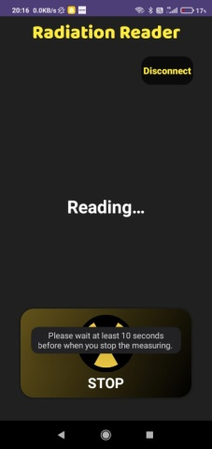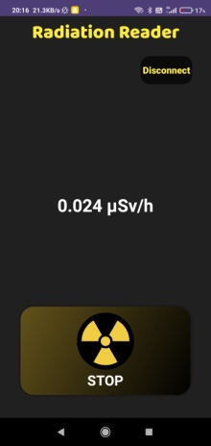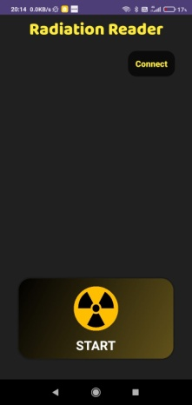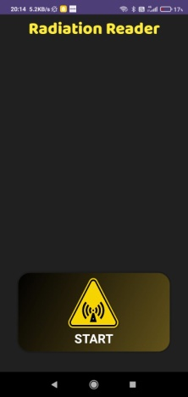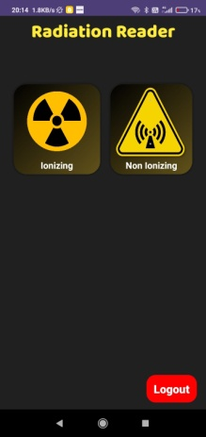

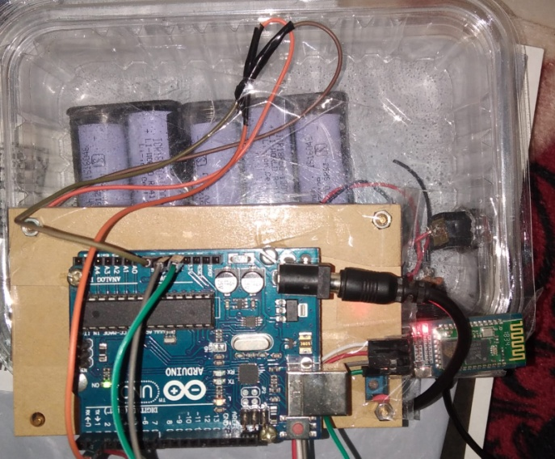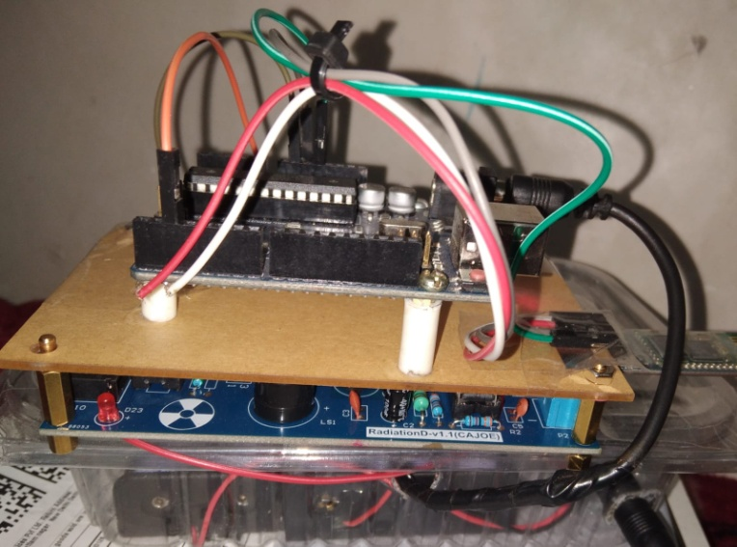

**Contributors of Data**

 

**Contributors:**

* Snehil Dalal
* Fatima
* Fakhruddin K.G.
* Suhail
* Altaf Hussain